**Assignment: 4**

**Experiments**

1. **Use following predefined functions and interpret the results:**

**Min () and max ()**

**Bin (), Oct (), Hex ()**

**Pow ()**

**Eval () and exec ()**

**Chr () and Ord ()**

**Round ()**

**Random (), rand int (), Import random module Random.rondom () Import math module**

**Sin (), Cos (), Tan (), Ceil (), Floor (), Degrees ().**

**Coding:**

num1=int(input("Enter the 1st number="))  
num2=int(input("Enter the 2nd number="))  
minimum=min(num1,num2)  
print("The minimum number=",minimum)  
maximum=max(num1,num2)  
print("The maximum number=",maximum)  
x=bin(num1)  
print("The changed num1 number with the help of bin function=",x)  
y=oct(num2)  
print("The changed num2 number with the help of oct function=",y)  
z=hex(num1)  
print("The changing num1 into hexadecimal form with the help of hex function=",z)  
power=pow(num1,num2)  
print("The power of num2 with help of pow function=",power)  
S="print('This is subtraction of 45 and 5 using eval()',45-5)"  
eval(S)  
program = 'print("The sum of 5 and 20 is", (5+20))'  
exec(program)  
y1=chr(51)  
print("This chr() is for finding a ASCII value ",y1)  
y2='A'  
ord(y2)  
x1= round(41.5)  
print("This is the round() using a floating number and it gives nearest integer number=",x1)  
import random  
print("This returns random number between 0.0 and 1.0",random.random())  
print("This randint() returns between number of both numbers=",random.randint(1,20))  
import math as m  
print("The value of sin()",m.sin(90))  
print("The value of cos()",m.cos(0))  
print("The value of tan()",m.tan(45))  
print("The value of ceil()",m.ceil(34.7))  
print("The floor()",m.floor(22.31))  
print("pi / 180 Radians is equal to Degrees : ", end ="")  
print (m.degrees(m.pi / 180))

**Output:**

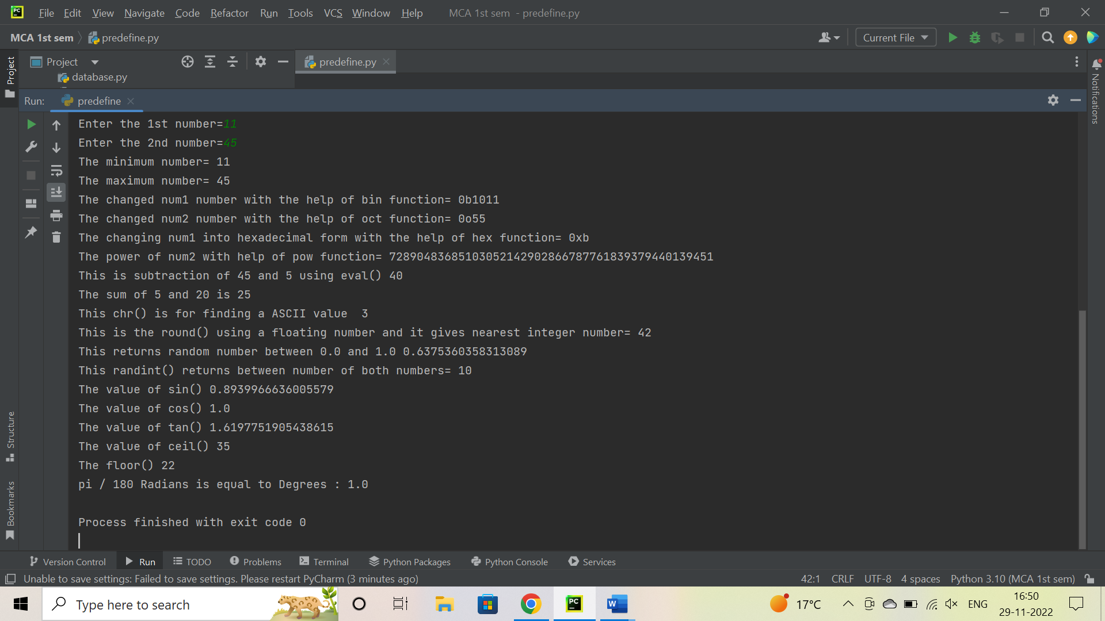

1. **Write a function to sort the contents of an integer list.**

**Coding:**

List = []  
n = int(input("Enter number of elements : "))  
for i in range(0, n):  
 ele = int(input())  
 List.append(ele)  
print(List)  
List.sort()  
print(List)

**Output:**

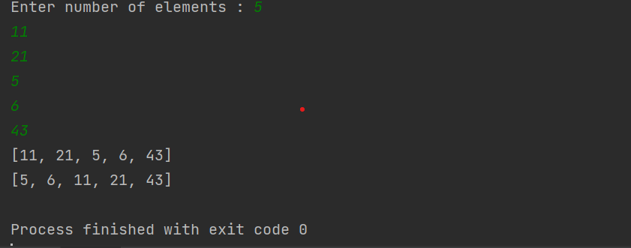

1. **Write a function to change the case of a given string.**

**Coding:**

Letter = input("Enter the string for changing a case of string:")  
L = Letter.upper()  
print("This is changed case of string:", L)

**Output:**

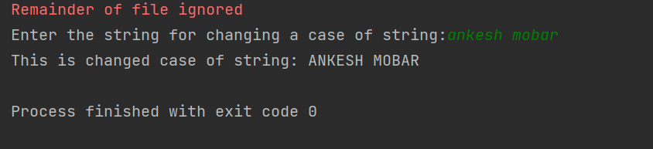

1. **The Fibonacci Sequence is the series of numbers: 0, 1, 1, 2, 3, 5, 8, 13, 21, 34, ... Write a function recursive) to print n terms of this series based upon user input.**

**Coding:**

def recur_fibo(n):  
 if n <= 1:  
 return n  
 else:  
 return(recur_fibo(n-1) + recur_fibo(n-2))  
Fiboseries = int(input(" Enter a number :"))  
if Fiboseries <= 0:  
 print(" enter a positive integer ")  
else:  
 print("Fibonacci sequence:")  
 for i in range(Fiboseries):  
 print(recur_fibo(i))

**Output:**

